**Experiment 1:**

**Aim:** To write a python program to implement a 8 puzzle program.

**Algorithm:**

1.Define the problem with an initial and goal state.

2.Use Manhattan distance as the heuristic.

3.Implement the A* algorithm to evaluate states.

4.Generate valid successors and avoid revisiting states.

5.Stop when the goal state is reached or declare unsolvable.

Program:

from queue import PriorityQueue

# Define the goal state

def find_position(state, value):

"""Find the position of a value in the puzzle state."""

for i, row in enumerate(state):

for j, val in enumerate(row):

if val == value:

return i, j

return None

def calculate_manhattan_distance(state, goal_state):

"""Calculate the Manhattan distance heuristic."""

distance = 0

for i in range(len(state)):

for j in range(len(state[i])):

if state[i][j] != 0: # Ignore the blank tile

goal_pos = find_position(goal_state, state[i][j])

distance += abs(i - goal_pos[0]) + abs(j - goal_pos[1])

return distance

def get_neighbors(state):

"""Get all possible states from the current state."""

neighbors = []

size = len(state)

blank_pos = find_position(state, 0) # Find the blank tile position

x, y = blank_pos

# Directions: up, down, left, right

directions = [(-1, 0), (1, 0), (0, -1), (0, 1)]

for dx, dy in directions:

nx, ny = x + dx, y + dy

if 0 <= nx < size and 0 <= ny < size:

# Create a new state with the blank tile swapped

new_state = [row[:] for row in state]

new_state[x][y], new_state[nx][ny] = new_state[nx][ny], new_state[x][y]

neighbors.append(new_state)

return neighbors

def a_star_8_puzzle(start_state, goal_state):

"""Solve the 8-puzzle using A* search."""

open_list = PriorityQueue()

open_list.put((0, start_state))

came_from = {}

g_cost = {tuple(map(tuple, start_state)): 0}

f_cost = {tuple(map(tuple, start_state)): calculate_manhattan_distance(start_state, goal_state)}

while not open_list.empty():

_, current = open_list.get()

# Check if the goal is reached

if current == goal_state:

path = []

while tuple(map(tuple, current)) in came_from:

path.append(current)

current = came_from[tuple(map(tuple, current))]

path.append(start_state)

path.reverse()

return path

current_tuple = tuple(map(tuple, current))

for neighbor in get_neighbors(current):

neighbor_tuple = tuple(map(tuple, neighbor))

tentative_g_cost = g_cost[current_tuple] + 1 # All moves have a cost of 1

if neighbor_tuple not in g_cost or tentative_g_cost < g_cost[neighbor_tuple]:

g_cost[neighbor_tuple] = tentative_g_cost

f_cost[neighbor_tuple] = tentative_g_cost + calculate_manhattan_distance(neighbor, goal_state)

open_list.put((f_cost[neighbor_tuple], neighbor))

came_from[neighbor_tuple] = current

return None

def input_puzzle(prompt):

"""Take a puzzle input from the user."""

print(prompt)

puzzle = []

print("Enter the puzzle row by row, with 0 for the blank tile. Separate numbers with spaces.")

for i in range(3):

while True:

try:

row = list(map(int, input(f"Row {i + 1}: ").strip().split()))

if len(row) != 3:

raise ValueError("Each row must have exactly 3 numbers.")

if not all(0 <= x <= 8 for x in row):

raise ValueError("Numbers must be between 0 and 8.")

puzzle.append(row)

break

except ValueError as e:

print("Invalid input:", e)

return puzzle

# Main function

def main():

print("8-Puzzle Problem Solver using A* Algorithm")

start_state = input_puzzle("\nEnter the start state:")

goal_state = input_puzzle("\nEnter the goal state:")

print("\nSolving the 8-puzzle problem...\n")

path = a_star_8_puzzle(start_state, goal_state)

if path:

print("Solution found!")

for step, state in enumerate(path):

print(f"\nStep {step}:")

for row in state:

print(" ".join(map(str, row)))

else:

print("No solution exists for the given start and goal states.")

if __name__ == "__main__":

main()

**Output:**

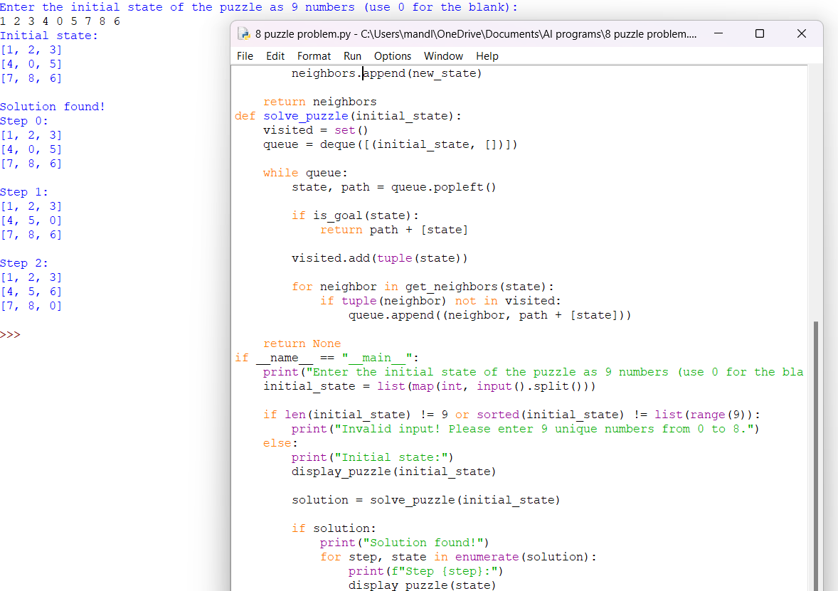

**Result:** Thus, the program was successfully completed using python programming.